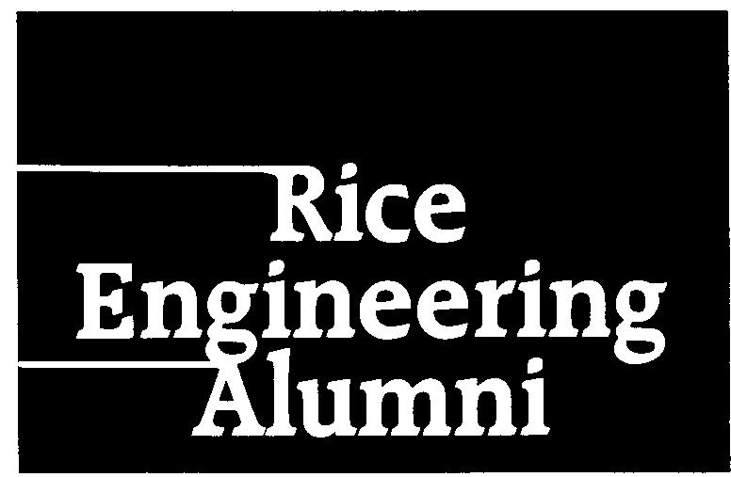

REA alumni survey February 2004
E-mailed to 4211 alumni, 828 responses

Highlights
80% of alumni feel at least somewhat disconnected from other engineering graduates.

70% of alumni have never been dues-paying members of the REA.
Reasons:
“out of touch too long”
“live outside of Houston”
“don’t work as an engineer anymore”
“don’t see a benefit”

64% of alumni feel that no benefits for membership are necessary.

Aside from those who live outside Houston (40%), the reasons for not attending events were evenly split (too busy, time/location not convenient, didn’t expect to know attendees, didn’t interest me).
Other reasons:
“I assume I would be very out of place at an event with other working engineers.”
“Did not hear about them.”
“Believe that it would have taken much too much effort to have gone to one.”
“Most of the REA stuff that I do see tends to be more oriented towards the hard engineering (chemical, mechanical, etc.) It also tends to be more academic in nature.”

55% of alumni rated the REA newsletter as either “never read it” or “not important.”
Other feedback:
“Short writeups of engineering problems and their solutions. Also, ideas or stories about managing projects.”
“To enhance "connectedness," need to include more news about alumni and events outside of Houston.”
“Trends in engineering fields as they relate to jobs, consumer products and research and how Rice is keeping up.”
“Highlighting research done in the Engineering School more - perhaps a ‘development of the year.’”

Community Service projects
Greatest support for “Efforts by Rice faculty or staff to reach out to K-12 schools” (18%), followed by Habitat for Humanity (16%). However, the largest percentage (27%) said they were unlikely to participate in community service projects.

New Programs
58% are at least somewhat unlikely to use services for posting resumes through the REA website.
58% are at least somewhat unlikely to use services for posting jobs through the REA website.
71% are at least somewhat unlikely to take technical courses offered by Rice for PE certification.
60% are at least somewhat unlikely to take on-line courses in engineering through Rice.

Additional feedback
“I don't see REA serving alumni outside the Houston Area, which is unfortunate. There are a lot of us out here.”

“I think that a co-op program on-campus could be of tremendous benefit to Rice students, particularly the engineering students. This would especially be true during periods when the economy is struggling and companies are likely to only hire co-op students. This is an activity that REA should push and could play a significant role in.”

“Networking opportunities and professional development opportunities are the most important factors for me participating in the REA, but they must be accessible for people living out of Texas to be useful to me.”

“Since I don't live in Houston anymore, it's a lot more difficult for me to be involved in REA and in the Rice community in general. It would help a lot if REA could develop more activities that can be done ‘remotely’ (like mentoring a Rice student via e-mail) and do not require coming to campus in order to participate.”

“Rice can be amazingly provincial. For a world class university the assumption seems to be everyone lives in Texas, most likely in Houston. As I have never lived in Texas since graduation, I find this very limiting. Regional meetings (combined with other engineering schools) would be a nice way to meet alumni and network with other similar minded individuals.”

“At Homecoming, I was not interested in the ‘Awards’. I would have been much more interested in a tour of the engineering labs, a chance to visit with the faculty (socializing), and an opportunity to current projects of the students and faculty. I would also have liked to see more engineering faculty participating in lectures to the alumni. There was a ‘show and tell’ in nanotechnology, but it was designed to raise funds. I would like to have seen more educational outreach to the alumni, especially to alumni who have moved on to other fields.”

REA Undergraduate Survey February 2004
E-mailed to approximately 800 undergraduates, 223 responses

Highlights
82% were unaware that they would become de facto members of the REA upon graduation.

75% say they would be likely to participate in mentoring programs in their specific field.
Feedback on current mentoring programs:
“Make them more widely publicized in the departments.”
“I had no idea that there were mentor programs for engineers.”
“I think the most important thing an undergraduate student can learn from the alumni is what each engineering field specifically does, more than just broad ideas. I want to know exactly what mechanical engineering majors are doing. Having this knowledge would help undergraduates better understand what they are getting into. After conversations with many faculty, I still wish to have better knowledge of the specific majors.”
“Yes! Tell me about them! Where do I sign up? I'm floundering here! My future is uncertain and it's scary! I'm going to look for them right after I finish this survey!”

Other programs
“Hands-on sessions on practical engineering skills such as surveying and concrete mixing.”
“I would be interested in talking with female alumni about the very real challenges of choosing between raising children vs. a career, the challenges of trying to be a working mom, and the problems that come with postponing childbearing. I would love to talk with alumni who have chosen to be stay-at-home moms.”

General feedback
“A strong connection with the real world is important -- the REA could help teach students about business, working in industry or going to grad. school, writing proposals, etc.”
“More ‘social’ activities during the year... just the ‘getting to know you’ sort of thing!”
“It would be nice to have talks from persons in the industry every now and then as to what it's really like out there. Knowing homework-obsessed engineering students, good attendance may be hard to come by. It's a thought, however.”

